**Digital Marketing HW Assignment**

Your Name: Rahul Kotian

* + - 1. **DELIVERABLE ONE: (0 points BUT 10 POINT DEDUCTION IF NOT DONE)**

1. Enter the url of your target company that meets the criteria from page one:

URL : <https://www.scheels.com/>

1. Provide two screenshots of the website containing the homepage and a page for the product or service categories you are using in your Ads campaign/ad groups- make sure screenshot shows the category page and subcategoriesA screenshot of a website

   Description automatically generated

## UX-Usability -10 points

1. **DELIVERABLE TWO:** Identify at **least four** UX problems based on best practices discussed in the lectures, show with a screenshot what the problem is, see the examples below. Do NOT cite the lack of a “Site Map” There can be more than one problem per screenshot-however, it must be very clear what the problem is. Highlight it and add a text box comment as shown below. You **must find at least 4 problems, if you cannot, use another website.**

## Google Ads Section -55 points

As shown in the video, enter screenshots for each of these sections listed below

1. Click on the all Campaigns tab (should have 3 campaigns-Search, Display & Video)-for each copy and paste detail page showing all your campaign settings that I required when doing that campaign-may require several screenshot. E.g, Location, frequency capping, audiences, topics, keywords. For smart campaign show ad , keywords and localization here as shown in my video

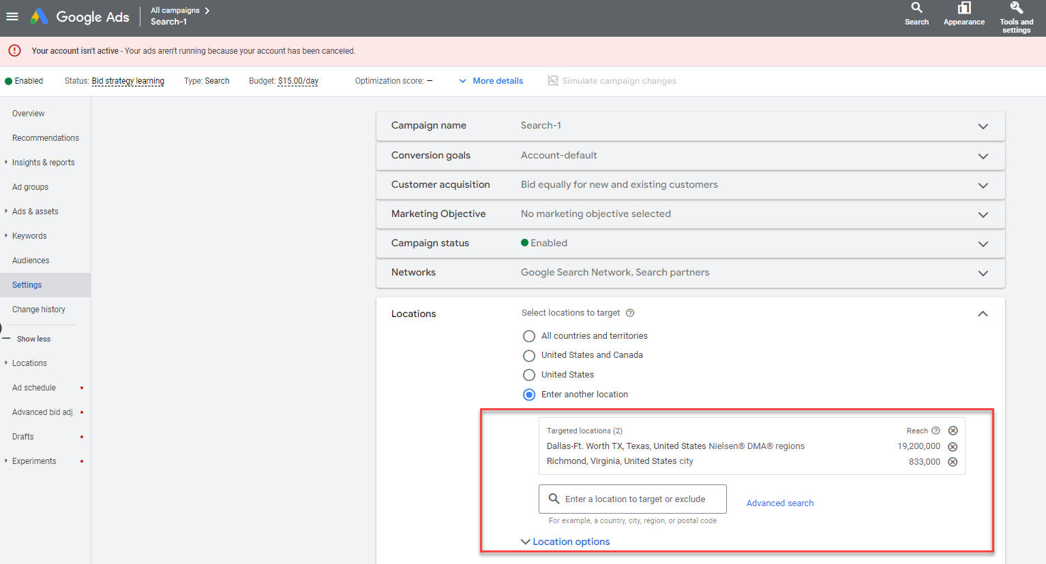

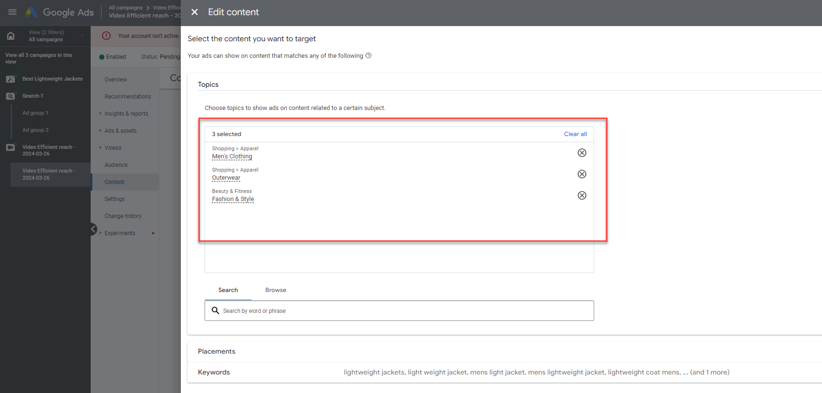

1. Ad groups tab (should have a total of 3 Ad Groups-2 for search and one for video)

1. Ads tab- make sure I can see all your ads including the display and video ads.

1. Keywords tab- show all the keywords used.

1. Negative keywords: make sure all your negative keywords are shown and if campaign vs adgroups-minimum of 6 negative keywords

f. Ad extensions created- must have at least two: site links (with at least 2 links) and one other extension, it can be any type

## Extra Credit-5 points

## Create a Facebook Ad, for this best to use your own Facebook login, very hard to get past their security process if a fake Facebook business page and account-reason don’t use in homework and very similar to Google Display. Use core audiences as shown in the video

## C. SEO Section-(35 points overall) continue using the same website as you did for PPC

## DELIVERABLE SEVEN (4 points): Is the site mobile friendly and what is the speed rating given by Google (show screenshot)

## First go to <https://www.bing.com/webmaster/tools/mobile-friendliness> enter url and take screenshot of results page, no need to make comments

## Now go to <https://gtmetrix.com> (or backup <https://tools.pingdom.com/> and enter your domain, and run the test, highlight results highlight problem areas (if they are all great still show this), Identify and highlight which items are slowing down your website the most. No comments needed

## DELIVERABLE EIGHT (3 points): Using SEOsitecheckup’s (or any other SEO tool such as [Screaming Frog)](https://www.screamingfrog.co.uk/seo-spider/)

## Go to checkup tab and take screenshot showing at least 3 problem areas -- No need for an explanation-

## Go to the broken links tool or tab of free tool as shown in video <https://www.brokenlinkcheck.com/> and take screenshot of broken links, if none still show screenshot. No comments needed

## DELIVERABLE NINE. (3 points) Localization, using <https://moz.com/local/overview>, show a screenshot of what listings they have and don’t have. If no results make sure you look through all the “addresses” they provide, show screenshot of what addresses were available if no results. Highlight incomplete and inconsistent or duplicate listings as shown below, no need for comments

## DELIVERABLE 10-(25 points)

## Using the MOZ toolbar for your target website (you must be logged into MOZ)

## Take a screenshot of your website’s home page and highlight its Domain Authority (DA), Page Authority (PA), and Spam Score, as shown below. Make sure it is easily visible as the tool’s black background makes it hard to read with a screenshot unless cropped and made larger. No comments needed

## 

## Click on the spam score and take a screenshot of issues as shown below, and highlight the top 4-5 “spammy” issues, in the real world you would request those websites remove their links to you and if they don’t, submit a link disavowal with [Google](https://support.google.com/webmasters/answer/2648487?hl=en), Bing, etc. No comments needed

## 

## Pick one long tail keyword (must have at least three words). If your keyword is already in the top 3 results, then pick another one that is not. I suggest you add a location like Frisco, Dallas etc. relevant to your website and show screenshots of the SERP. Then add a comment about your recommendation based on the PA and DA of other websites

## Enter what long tail keyword you use: MEN'S LIGHTWEIGHT JACKETS in the colony

## Show a cropped screenshot of the category/subcategory or product detail page with its PA and DA. No comments needed

## iii) Show a screenshot of at least the top 3 Google SERP results and add comments based on your target websites SERP organic ranking with a recommendation, as shown below.

“Scheels” is not in the top 20 positions for “MEN'S LIGHTWEIGHT JACKETS in the colony” . The top 3 sites have a Domain authority of over 90, so it will be difficult to get into top 3 SEO rankings.

Recommendation for this keyword: Suggested to focus on doing PPC shopping ads in Google Ads and find other keywords to focus on for SEO purposes

## iv) Use the MOZ toolbar (can also use toolbox.seositecheckup.com but it won’t show anchor text) as shown in the video, and open “Link explorer” then on left hand menu go to the “Inbound links” tab , leave root domain option and use the filter “Follow” and “NO redirects” then add comments about what is wrong with their links as mentioned in video and instructions

## Not too much variety when we look at inbound links, looks like pinterest has some mentions, but not any major news outlets or sport/fashion blogs. We might do well to approach them to review our lines of products.

## Anchor text needs more variety.

## v. Now go to the “Compare Links Profile” tab and pick from your competitors one with a better DA score than your client website, then enter that one next to your website, Show a screenshot, analyze and make comments as to why from a Link only perspective the better ranked website is beating you in DA and PA. (Note if none are better than your website ,find some other competitors that are)

## REI has more than 15 million External followed links compared to our 1.4 million links which is an important factor.

## Go to “Discovered and Lost Linking Domain” tab and take a screenshot only, no need to comment

## 

## Link Ideas: Pick any competitor website doing better than your target website and enter them in the Inbound links page, use same filters as used in previous link analysis task then look through and recommend 3 websites that they could approach for links, DO NOT REPEAT SAME TYPE OF WEBSITE OR SOCIAL MEDIA, FOR EXAMPLE IF PINTEREST APPEARS THREE TIMES DO NOT USE THAT MORE THAN ONCE. provide comments

## NY times (PA: 69, DA:95) has a couple of articles suggesting camping and hunting gear for the competitor “Cabela’s”. We could approach NY times with similar articles and give them a list of our best-selling camping and hunting gear for the upcoming summer holidays.

## Buzzfeed (PA:65, DA:93) has featured Cabela’s sleeping bags as part of their must haves for camping trips. We could approach Buzzfeed with our lines of camping gear to feature in their next articles.

## Time (PA:63, DA:94) has posted about Cabela’s hunting gear; we could approach them to do an article regarding our (Scheels) hunting gear.